***MARYLAND CHAPTER 99s* CRABPOT**

***March 2019***

****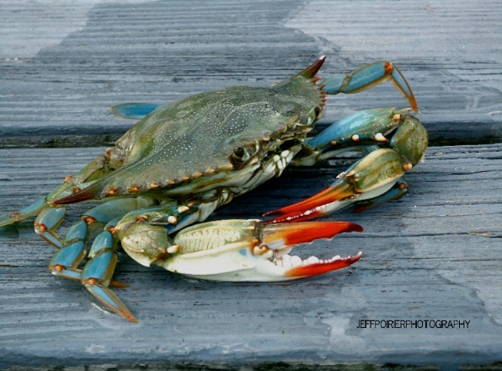

**Our Maryland Chapter Officers**

|  |  |  |  |
| --- | --- | --- | --- |
| **Chairman** | Cathy Steele | [moira46@gmail.com](mailto:moira46@gmail.com) | 443-326-4625 |
| **Vice Chairman** | Donna Suwall | [dsuwall@aol.com](mailto:dsuwall@aol.com) | 410-608-7542 |
| **Secretary** | Jane Toskes | [planejane49@gmail.com](mailto:planejane49@gmail.com) | 443-756-7890 |
| **Treasurer** | Alice Li | [lizhengzju@gmail.com](mailto:lizhengzju@gmail.com) | 404-984-0617 |
| **Membership** | Ginny Carlin | [vcarlin21@comcast.net](mailto:vcarlin21@comcast.net) | 410-879-9503 |
| **Aviation & Space Education** | Lauren Daffin | laurjdaff@yahoo.com | 301-247-1965 |
| **A E Scholarship** | Carol Christian | carolc91@gmail.com | 410-921-2359 |

**Chapter Dues are PAST Due**

Please make the check for $20.00 payable to MD 99s and send to new address for Alice Li: 9844 Middle Meadow Road, Ellicott City, MD 21042. Dues are $10 for student pilots.

**NEXT MEETING April 13, 2019**

Meet at 11am Martin State Airport in Classroom Lower Level of Hangar #4.

We are inviting all student pilots and anyone else who would like to discuss training, progress, and mentors.

**REPORT of LAST MEETING – March**

The March meeting was cancelled so that we could participate on March 30th for the Girl Scout Program with the Glenn L Martin Maryland Aviation Museum, 9:30 – 3:00. If anyone is interested in participating please contact Cathy Steele.

We also discussed our new website ([www.maryland99s.org](http://www.maryland99s.org)) which new student pilot member Sophia Dengo is creating. Now we need more content to add. Do you have any stories of a 99s adventure to add? Photos would also be great so if you have any please send them to Sophia at [sdengo@gmail.com](mailto:sdengo@gmail.com).

**UPCOMING ELECTIONS**

**Would You Like To Serve the MD Chapter This Year?**

**MD 99s, o**ur yearly elections for Chapter Officers for the 2019-2020 term will be in May with the newly elected officers taking office in June. Ginny Carlin and Donna Suwall are in the process of preparing the Ballot, which will be available in both paper and electronic forms.

If you'd like to serve the Chapter in one of the following positions, please contact either Donna at [DSUWALL@aol.com](mailto:DSUWALL@aol.com) or Ginny at [VCARLIN21@comcast.net](mailto:VCarlin21@comcast.net)

Here are the 4 positions and the names of members who have at this time agreed to be placed on the ballot. Each position can have more than one candidate. If you'd like to have your name put on the ballot for any of the positions, please let either Ginny or Donna know ASAP. The Ballot will close April 13, 2019.

**Chairman...............Jane Toskes**

**Vice Chairman.......**

**Secretary................**

**Treasurer................Alice Li**

**Announcement**

We now have a team participating in the Air Race Classic June 18-21!! Jane and Carol will be flying Carol’s Cirrus SR22! Team name Cirriously Amazing!! They have begun finding sponsors to help with funding. See the website at *www.airraceclassic.maryland99s.org* The team will accept any donations offered! Buy us a cip of coffee or a couple gallons of Avgas.

**UPCOMING CHAPTER CALENDAR**

*March 30*th – 1)chapter meeting at Girl Scout badge activity at MTN.

2)booth at Essex SkyPark for STEM meet and greet changed to April 13

*April 13th* – 1)the visit to the NTSB in Washington DC has been postponed. Meet at MTN in the classroom for discussion.

-2)booth for STEM meet and greet at Essex SkyPark now April 13 10am

*May 11th* – several options for May – section meeting May 17-19 instead of our regular Saturday meeting, or the AOPA Fly in FDK May 10-11, or a regular meeting with a review of the SFRA rules and operating practices.

*June 8th* – Round table discussion of aircraft accident reports. What could have been done to prevent it? What would have broken the chain of events? Led by Cathy Steele.

*July 16-21* – International Convention in Dayton, OH. If you have not visited the museum at Wright Patterson, this is a great opportunity to do so.

Meeting ideas: 1)tour of Flight Safety International training center at ILG, to be arranged by Loretta Cook.

2)Glenn L Martin Maryland Aviation Musuem at MTN has Open Cockpit Days scheduled for May 18, June 22, July 20, August 17, and September 21 – in the past we have set up our booth to meet and inform the visitors about aviation.

**99s UPCOMING EVENTS**

April 2-7 – Sun n Fun, Lakeland, FL. [www.flysnf.org/sun-n-fun-intl-fly-expo](http://www.flysnf.org/sun-n-fun-intl-fly-expo).

April 3 – WASP Luncheon at Sun n Fun.

May 17-19 – Mid Atlantic Section Meeting at RMN, Stafford Airport in Fredericksburg, VA. Information at the Old Dominion website [www.olddominion99s.com/section-meeting](http://www.olddominion99s.com/section-meeting)

June 18-21 – Air Race Classic. Starts in Jackson TN and ends at Welland, Ontario, CN. See www.airraceclassic.org for information.

**2019 99s International Convention** – July 16-21, 2019 – Dayton Ohio. Expect more information in the January/February Issue of the *Ninety-Nines Magazine*.